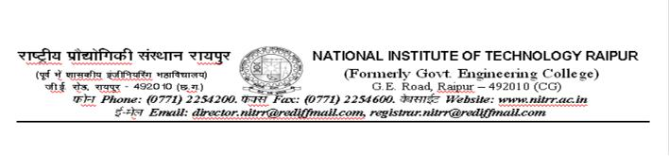

No./NITRR/Electrical/Project/2019/ Raipur, Dated: 23.08.2019

Applications are invited for the post of one Junior Research Fellow for a period of three years (reviewed annually) as per the following requirements. Eligible candidates can attend the Walk-in interview on 11.09.2019 at 11.00 AM in Electrical Engineering Department along with the completed application and necessary certificates.

Name of the temporary post : Junior Research Fellow

Research Project Title : Detection of Data attacks and Design of a resistance mechanism in smart grids

Principal Investigator

: Dr. Subhojit Ghosh, Associate Professor

Department of Electrical Engineering,

NIT Raipur, Chhatishgarh-492010;

Email: sghosh.ele@nitrr.ac.in

Funding Agency : DST (Interdisciplinary Cyber Physical Systems Program)

Tenure of the Project : Three years

Tenure of the assignment :Three years (Performance shall be reviewed annually).

Job description :Research related to the project work.

Consolidated monthly fellowship :Rs. 25,000 + 20% HRA

Essential qualifications : B.E./B.Tech with NET/GATE Qualification or M.E./M.Tech in Electrical Engineering/ Electrical and Electronics/ Computer Science/Electronics and Communication/Relevant branch. Good Programming skill with Knowledge of MATLAB/ Simulink and similar domain is desirable.

Date and Time of Interview :11.09.2019 at 11.00 AM in Electrical Engineering

Department.

Eligible persons may attend the walk-in interview along with application form, photocopies of self-attested educational qualification, experience certificates, grade/mark sheet, publications and affixed with colour photographs etc..

Terms and Conditions:

- The above position is purely temporary and Continuation of the fellowship is subject to availability of fund and satisfactory performance (to be reviewed each year).

- Candidates are required to appear for the interview with photocopy of the application form, curriculum vitae, and all relevant original certificates with a set of self-attested photocopies of the certificates and two passport photographs.

- No TA/DA is permissible for appearing for interview.

- Selected candidates will not be permitted to claim for any regular/part time appointments in this institute or any other institutes during this period.

- Canvassing in any form will disqualify the candidature.

- The appointment shall be co-terminus with the project.

- Concealing of facts in any form shall lead to disqualification or termination of such candidates.

For further details please contact

Dr. Subhojit Ghosh

Assiociate Professor & Principal Investigator

Department of Electrical Engineering

NIT, Raipur, CG, INDIA, 492010

Email: sghosh.ele@nitrr.ac.in

Dr. Tanmoy Kanti Das

Assistant Professor & Co-Principal Investigator

Department of Computer Application

NIT, Raipur, CG, INDIA, 492010

Email: tkdas.mca@nitrr.ac.in

Dr. Ebha Koley

Assistant Professor & Co-Principal Investigator

Department of Electrical Engineering

NIT, Raipur, CG, INDIA, 492010

Email: ekoley.ele@nitrr.ac.in

